**PE01 – Hello World**

Hema Deepika Thanigai Arasu.

City University of Seattle

School of Technology & Computing (STC)

CS624 Full-Stack Development- Mobile App

Dr. Sam Chung

04/09/2023

**PE01 – Hello World**

**Screenshot of Execution**

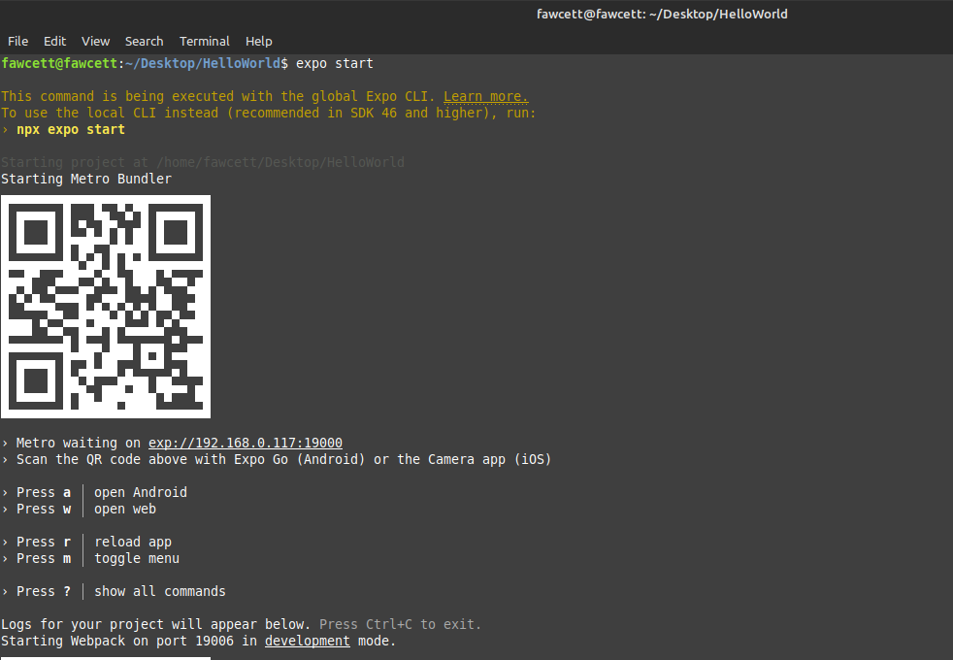

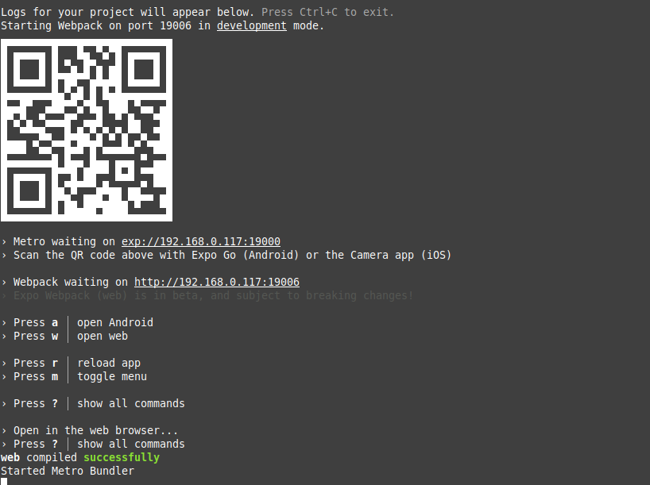

**Screenshot of Output**

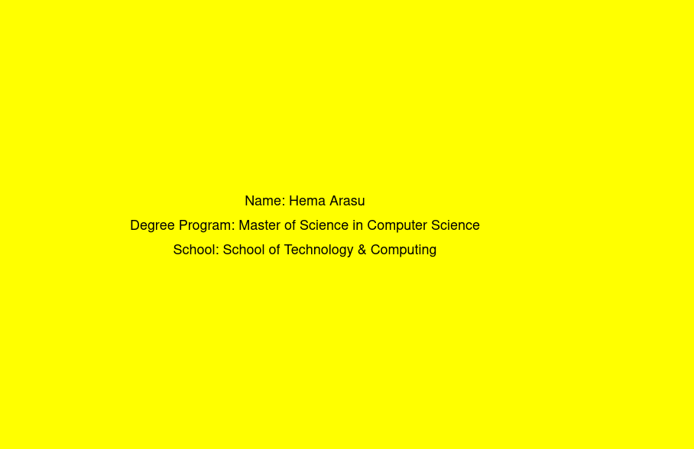

**Explanation**

The output of the app is a mobile screen that displays the following text messages:

* "My Name: Hema Arasu"
* "Degree Program: Master of Science in Computer Science"
* "School: School of Technology & Computing"

The text messages are displayed in a yellow background colour, as defined in the styles. In simple terms, it provides a simple way to show your name, degree program, and school information on a mobile device. The mobile app takes no input, but processes the fixed text messages and styles, and displays the output on the screen with the defined styles.